x86 Assembly Worksheet #30a Name _____________________________

Using the Debugger

In general, debugging is the process by which errors in programs are identified and corrected.

Compile-Time Errors vs. Runtime Errors
Syntax errors are identified by the assembler when you using the build command to convert your assembly code into an executable program. These errors, called compile-time errors, can be fixed readily since they are identified by the assembler.

Other errors, which are not identified by the assembler, become evident when you run the program. These errors, called runtime errors, are much more difficult to correct because they manifest themselves as incorrect program behavior. Before such an error can be fixed, time must be spent to identify exactly which line(s) of code contain the error.

What is a Debugger?
A debugger is a tool that simplifies the process of identifying runtime errors. The debugger that you use to debug your assembly programs is called the Turbo Debugger.

Running the Turbo Debugger
Before you can debug a program, you must first build it using the build asmProg command. To start debugging the program, type the command td asmProg – the td stands for Turbo Debugger. The following screen will then appear:

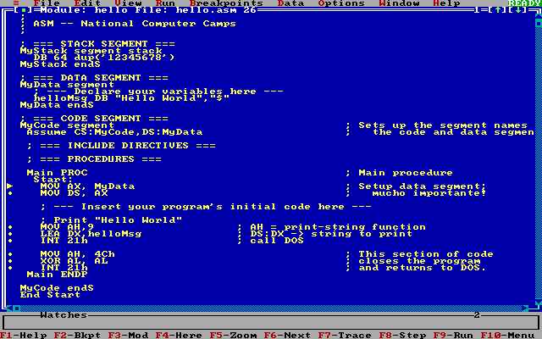

x86 Assembly Worksheet #30b Name _____________________________

Using the Debugger (continued)

The Debugger’s User Interface
The Menus
At the top of the debugger screen is a set of menus, beginning with File, Edit, and View. Inside these menus are various commands for the debugger. To open a menu and to see what choices are available, you can either click the menu’s title, or you can hold down Alt and type the first letter of the menu’s title.

The Module Window
The module window, located in the center of the screen, displays the code of the program that is being debugged. The two leftmost columns of this window are called the gutter. Inside the gutter, a dot is displayed to the left of every line in your program that contains an assembly instruction. Additionally, there is an arrow inside the gutter that always points to the current line, which contains the next instruction in your program that will be executed.

The Shortcut Bar
The shortcut bar is located at the bottom of the debugger screen. It displays a set of commonly used commands that can be executed by pressing the appropriate key. For example, when the shortcut bar displays F1-Help, you can execute the Help command by pressing the F1 key.

Stepping Through Each Line of a Program
When debugging a program, one typically uses the debugger to execute each line one at a time. After each line, you should check to make sure that the values of the registers and the program’s variables are what you expect them to be. Any deviation from the expected probably indicates an error in the program.
The following commands are useful for stepping through individual lines in a program.

Command | Function
Trace Into (F7) | Executes a single instruction. If the instruction is a procedure call, control is transferred to the first line of the procedure called by the instruction. Otherwise, control is transferred to the line following the instruction.
Step Over (F8) | Executes a single instruction. If the instruction is a procedure call, then the entire procedure is executed. Afterwards execution continues at the line following the instruction. If the instruction is not a procedure call then execution continues at the line following the instruction. This command is useful if you want to avoid stepping through the instructions of a procedure that you know is working correctly.
Until Return (Alt-F8) | Executes instructions until the current procedure returns to its caller.  This command is useful if you accidentally issued a Trace Into (F7) command, when you meant to issue a Step Over (F8) command, or when you have stepped through enough of a procedure to determine that it is working correctly.

Viewing the Current Values of the Registers
To see the current values of the registers, either:
- open the View menu and choose Registers, or
- press Alt-V and then press R.
A new window will appear that shows the current value of every register.

Viewing the Current Values of the Program’s Variables
To see the current values of the program’s variables, either:
- open the View menu and choose Variables, or
- press Alt-V and then press V.
A new window will appear that shows the current value of every variable in the program.
x86 Assembly Worksheet #30c Name _____________________________

Using the Debugger (continued)

Moving and Resizing Windows
To move a window, either:
- drag the window’s titlebar with the mouse until the window attains the desired position; or
- execute the Window Resize (Ctrl-F5) command, use the arrow keys to move the window, and press Enter when the window attains the desired position.

To resize a window, either:
- drag the window’s bottom-righthand corner with the mouse until the window attains the desired size,
- execute the Window Resize (Ctrl-F5) command, hold down Shift and use the arrow keys to move the window, and press Enter when the window attains the desired size.

Using Breakpoints
Sometimes executing instructions individually is undesirable. By setting a breakpoint on a line in the program and using the Run (F9) command, you can make the debugger automatically execute instructions until that line is reached. This is useful when you don’t want to step through each instruction in a section of code which you already know is working correctly.

To set a breakpoint on a line, click the dot in the gutter that appears to the left of the line. The line will turn red to show that a breakpoint was successfully set. If you want to clear the breakpoint later, click the dot again.

Below is a summary of the most useful commands related to breakpoints.

Command | Function
Toggle Breakpoint (F2) | Sets a breakpoint on the current line if there wasn’t one before, or clears a breakpoint on the current line if there was. This command is useful, in combination with the Run (F9) command, for making the debugger automatically execute instructions until a certain line in the program is reached.
Run (F9) | Executes instructions until either 1) a breakpoint is encountered,  2) Ctrl-Break is pressed, or 3) the program terminates.

Other Useful Debugger Commands
Command | Function
User Screen (Alt-F5) | Shows what would be displayed onscreen if the program was run normally, without the debugger. When you are done viewing, press any key to return to the debugger screen.
Program Reset (Ctrl-F2) | Restarts the program being debugged.
Exit (Alt-X) | Exits the debugger.

